July 10, 2025

Notice of Hearing on Objections

You are hereby notified that the Assessment Equalization Board appointed by the Council of the City of Akron to hear objections to the amount or apportionment of the estimated assessments for the North Main Street project per Res. No. 144-2025 will meet in Council Chambers, 166 S. High Street, 3rd Floor, on Tuesday, July 22, 2025, at 1:30 pm to hear such objections.

The board members have received a copy of your objection to review. Your attendance is not required for your objection to be considered by the board. The jurisdiction of the board is limited to determining (1) whether the property has been benefited by the improvement(s), and (2) whether the amount of the assessment is a proper apportionment of those benefits. The board cannot consider whether the project is necessary or revise the nature or the scope of the project, because City Council has already conclusively decided those matters.

By order of the Council of the City of Akron.

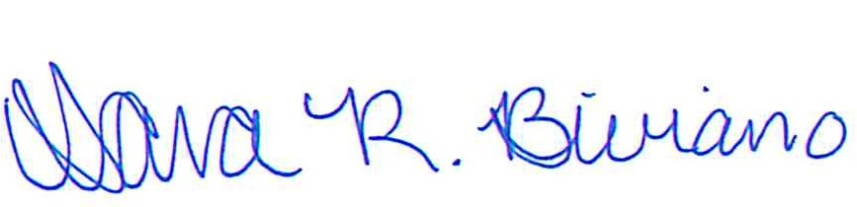
Sara R. Biviano
Clerk of Council

cc:

Jim Perge, Board Member
Jimmie Coleman, Board Member
Wylene Edwards, Board Member
Rebecca Trudeau, Assistant Law Director Durrell Towns, Assessor
Chris Ludle, Service Director
Jon Malish, Public Works Manager
Anthony Dolly, Public Works
Travis Capper, Engineering
Victor Botoson, Engineering

Matthew Neff, Engineering
Robert Solomon, Engineering

The City of Akron is committed to ensuring that individuals with disabilities are able to fully participate in public programs, services, and activities. Anyone who is in need of an accommodation from any City department is invited to contact the Department of Human Resources, 166 South High Street, Municipal Building, Suite 103, Akron, Ohio 44308, (voice) 330-375-2780 as soon as possible. If you require TDD phone service call Ohio Relay at 800-750-0750 and they will assist in contacting the Department of Human Resources at (330) 375-2780.

